Courtesy of time2reach.org


I Love You!
-God

Visit us at..
Akron Praise Temple
1316 Kentucky Ave, Akron, OH
330-753-4322

*Sunday School 10 am *
*Sunday Morning Service 11am*
*Wednesday Night 7pm*

time2reach.org

I Love You!
-God

Visit us at..
Akron Praise Temple
1316 Kentucky Ave, Akron, OH
330-753-4322

*Sunday School 10 am *
*Sunday Morning Service 11am*
*Wednesday Night 7pm*

time2reach.org

I Love You!
-God

Visit us at..
Akron Praise Temple
1316 Kentucky Ave, Akron, OH
330-753-4322

*Sunday School 10 am *
*Sunday Morning Service 11am*
*Wednesday Night 7pm*

time2reach.org
Courtesy of time2reach.org

Pastors Matt & Heather Stull
Welcome you!
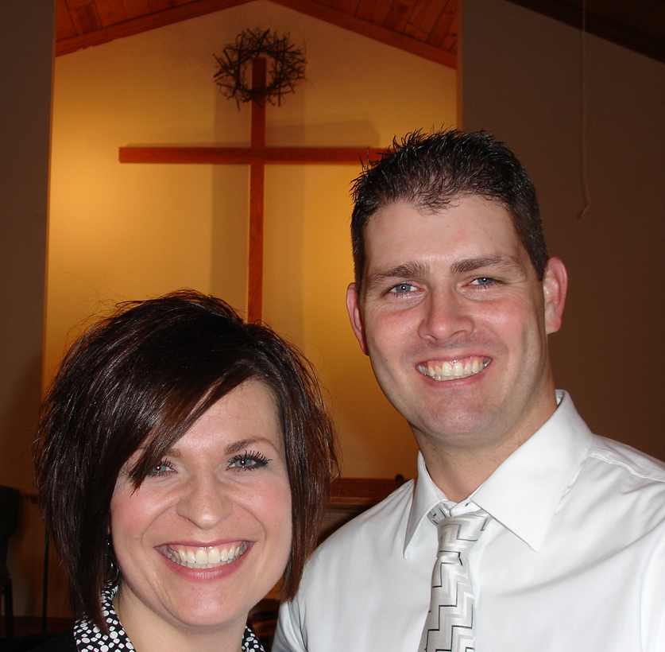
Please come and worship with us soon

OUR VISION
Vision Statement:
"We exist to be a hospital for the hurting, a greenhouse for those needing nourished and a safe haven for those that are lost. Our vision is to share the love of Christ and equip believers to fulfill the call of God upon their lives.”

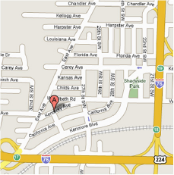

Pastors Matt & Heather Stull
Welcome you!
Please come and worship with us soon

OUR VISION
Vision Statement:
"We exist to be a hospital for the hurting, a greenhouse for those needing nourished and a safe haven for those that are lost. Our vision is to share the love of Christ and equip believers to fulfill the call of God upon their lives.”

Pastors Matt & Heather Stull
Welcome you!
Please come and worship with us soon

OUR VISION
Vision Statement:
"We exist to be a hospital for the hurting, a greenhouse for those needing nourished and a safe haven for those that are lost. Our vision is to share the love of Christ and equip believers to fulfill the call of God upon their lives.”

