Courtesy of time2reach.org


Come unto me all you who labor and are heavy laden and I will give you rest…

Struggling?
Feeling Lost?
Need Direction?
Follow me…
-God

Visit us in Kenmore at…..

Akron Praise Temple
(Kentucky Ave Church of God)
1316 Kentucky Ave, Akron, OH
330-753-4322

*Sun. School 10 am * Sunday Worship 11am*
*Wednesday Night 7pm*

time2reach.org

Come unto me all you who labor and are heavy laden and I will give you rest…

Struggling?
Feeling Lost?
Need Direction?
Follow me…
-God

Visit us in Kenmore at….

Akron Praise Temple
(Kentucky Ave Church of God)
1316 Kentucky Ave, Akron, OH
330-753-4322

*Sun. School 10 am * Sunday Worship 11am*
*Wednesday Night 7pm*

time2reach.org

Come unto me all you who labor and are heavy laden and I will give you rest…

Struggling?
Feeling Lost?
Need Direction?
Follow me…
-God

Visit us in Kenmore at….

Akron Praise Temple
(Kentucky Ave Church of God)
1316 Kentucky Ave, Akron, OH
330-753-4322

*Sun. School 10 am * Sunday Worship 11am*
*Wednesday Night 7pm*

time2reach.org

Courtesy of time2reach.org

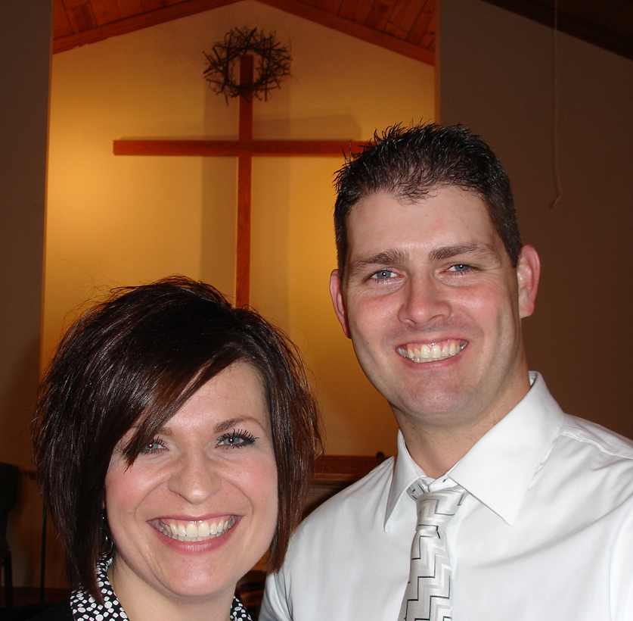 Pastors Matt & Heather Stull
We care about you!
Giving your life to Jesus, it’s as easy as ABC
A Admit you are a sinner
For all have sinned, and come short of the glory of God;
Romans 3:23

B Believe that Jesus died, was buried, and rose on the 3rd day.
For God so loved the world, that he gave his only begotten Son, that whosoever believeth in him should not perish, but have everlasting life. John 3:16

C Confess your sins and ask the Lord to forgive you, and to save your soul.
That if thou shalt confess with thy mouth the Lord Jesus, and shalt believe in thine heart that God hath raised him from the dead, thou shalt be saved.
Romans 10:9

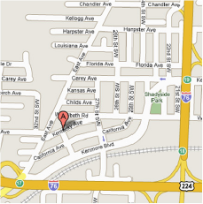

Pastors Matt & Heather Stull
We care about you!
Giving your life to Jesus, it’s as easy as ABC
A Admit you are a sinner
For all have sinned, and come short of the glory of God;
Romans 3:23

B Believe that Jesus died, was buried, and rose on the 3rd day.
For God so loved the world, that he gave his only begotten Son, that whosoever believeth in him should not perish, but have everlasting life. John 3:16

C Confess your sins and ask the Lord to forgive you, and to save your soul.
That if thou shalt confess with thy mouth the Lord Jesus, and shalt believe in thine heart that God hath raised him from the dead, thou shalt be saved.
Romans 10:9

Pastors Matt & Heather Stull
We care about you!
Giving your life to Jesus, it’s as easy as ABC
A Admit you are a sinner
For all have sinned, and come short of the glory of God;
Romans 3:23

B Believe that Jesus died, was buried, and rose on the 3rd day.
For God so loved the world, that he gave his only begotten Son, that whosoever believeth in him should not perish, but have everlasting life. John 3:16

C Confess your sins and ask the Lord to forgive you, and to save your soul.
That if thou shalt confess with thy mouth the Lord Jesus, and shalt believe in thine heart that God hath raised him from the dead, thou shalt be saved.
Romans 10:9

